Baked IDs and values
- login-row
  - shown when logged out
  - “sign in with Microsoft” button and help
- logged-in-row
  - shown when logged in
  - can show rest of job form with this
  - “Currently logged in as: ” + “not you”
  - current-user-lbl
    - “Currently logged in as: <b> user </b>”
- post-login-form
  - div with rest of the job request form
  - show when logged in
  - type-select
    - project type drop-down
    - 1 = Premiere
    - 2 = After Effects
    - 3 = Cycles
    - 4 = EEVEE
    - 3 and 4 shows extended frame selection settings
  - blender-render-settings
    - div with blender frame selection settings
    - start-frame-input
    - end-frame-input
    - use-all-frames-check-box
      - disable above two when checked
      - registers all frames to be rendered
  - project-location-input
    - URL string to project location
  - warning-error-p
    - to show the default alert and any form validation errors
  - job-submit-btn
    - form submit button
- job-que-table
  - displays the job que
  - order
    - User
    - Type
    - Time Added
    - Status
      - x/total rendered
      - Rendering
      - Place <b> # </b> in Que
- server-status-table
  - displays the nodes and their states
  - sorted: online-rendering-offline
  - order: Node, Status
    - Offline, Ready, Rendering
- resync-server-btn
  - pull updates from server to repopulate the tables

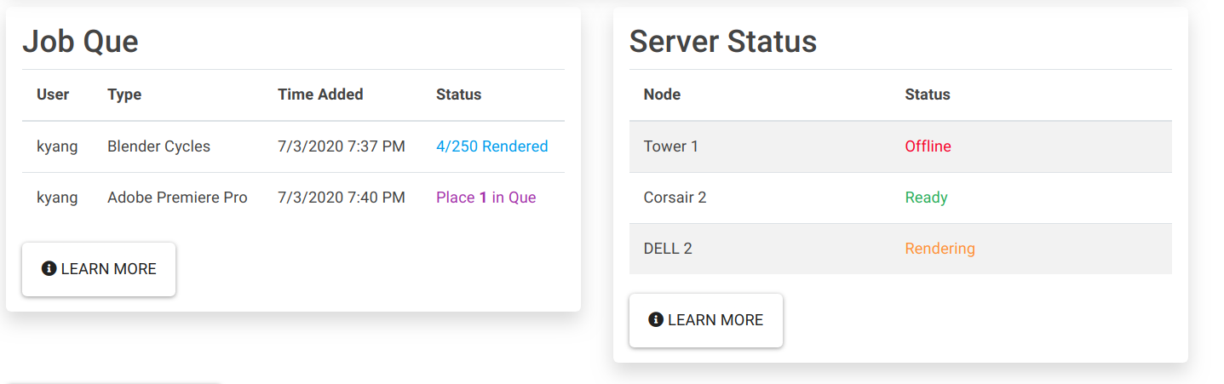

Do the things
- hide: add “d-none” class
- warning background: “bg-warning” class
- colors
  - primary (blue): “text-primary” class
  - info (purple): “text-info” class
  - warning (yellow): “text-warning”
  - danger (red): “text-danger”
  - success (green): “text-success”

